

ACA Module 9 Lab: Creating a Highly Available Environment

____________________________________________________

COS 20019- Cloud Computing Architecture

Nguyen Manh Dung

30/6/2023

So this all my step to finish ACA Module 9 Lab with explanation with all the screenshotted is included a requirement of the project

**Task 1: Inspecting your VPC**

Review the configuration of the VPC that was created for this lab.

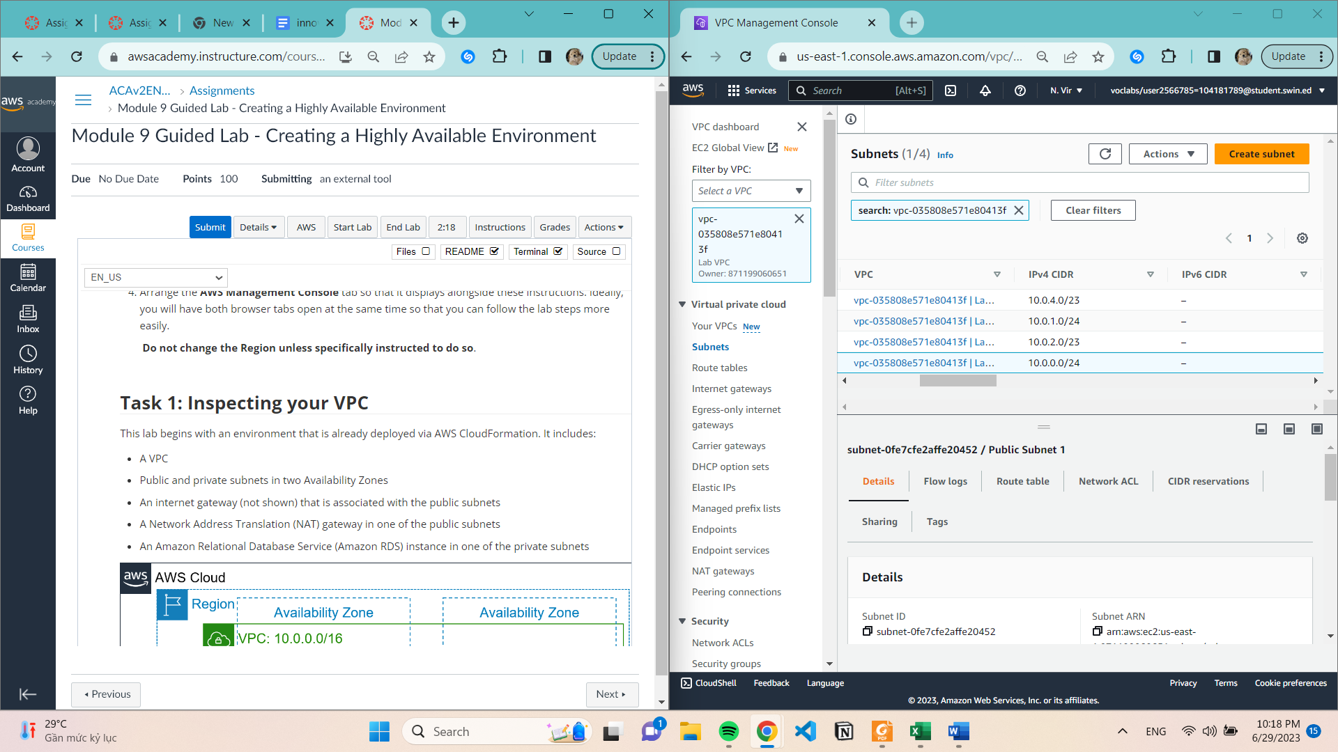

**Task2: Creating an Application Load Balancer**

Create Security Group with below configuration

**Security group name:** Inventory-LB

**Description:** Enable web access to load balancer

**VPC:** Remove the default VPC by choosing the X to the right of it. Then select **Lab VPC.**

Under **Inbound rules**, choose Add rule and configure as described:

**Type**: HTTP

**Source**: Anywhere-IPv4

Still under Inbound rules, choose Add rule again and configure:

**Type**: HTTPS

**Source**: Anywhere-IPv4

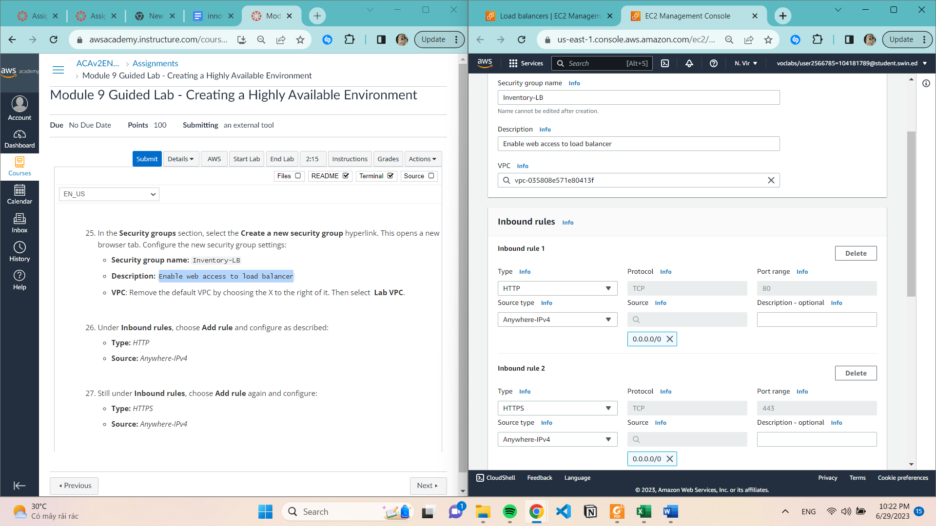

**Create Target Group**

* Configure the target group as described here:
* **Choose a target type:** Instances
* **Target group name:** Inventory-App
* **VPC**: Ensure that Lab VPC is chosen.
* Scroll down and expand **Advanced health check settings.**
* **Healthy threshold:** 2
* **Interval**: 10 (seconds)

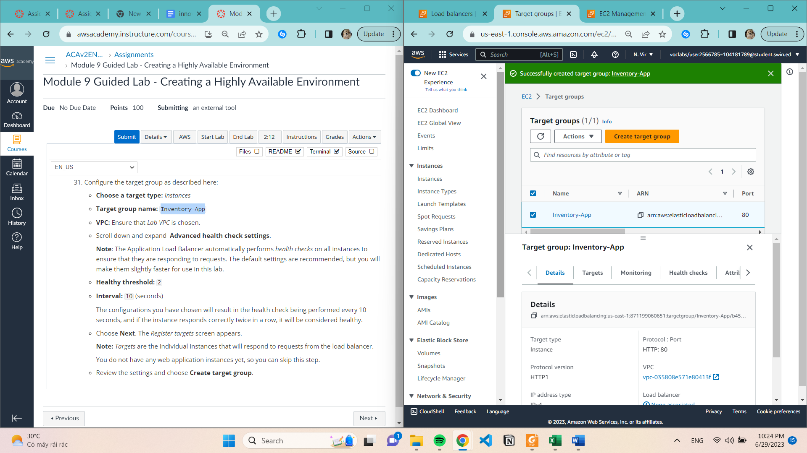

**Successful create load balancer**

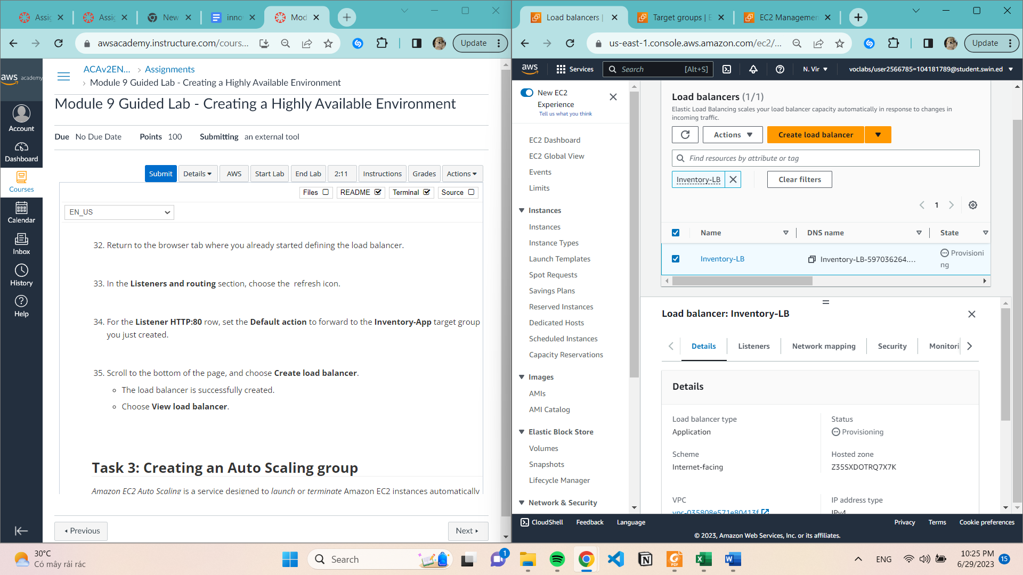

**Task 3: Create Auto Scaling group**

Create image

* **Image name**: Web Server AMI
* **Image description**: Lab AMI for Web Server

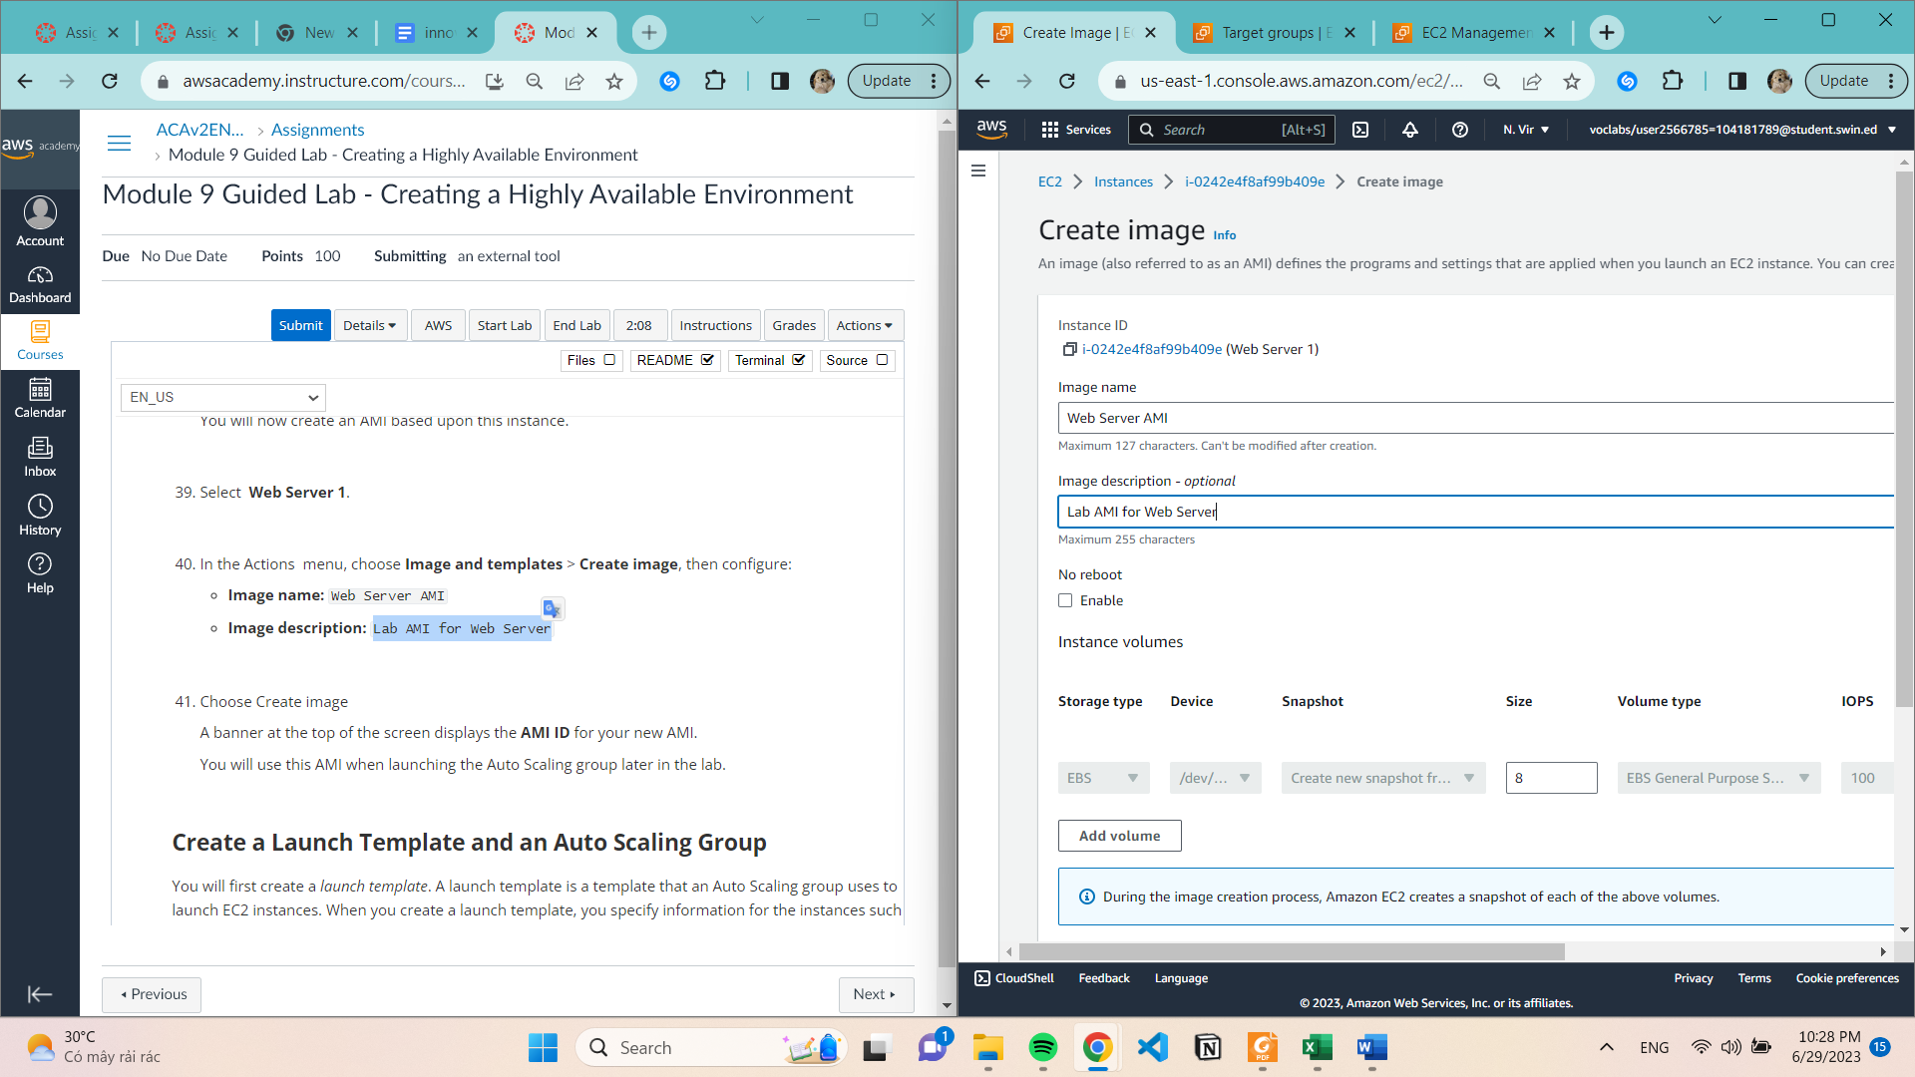

**Create a Launch Template and an Auto Scaling Group**

**Launch template name:** Inventory-LT

Under **Auto Scaling guidance**, select *Provide guidance to help me set up a template that I can use with EC2 Auto Scaling*

In the Application and OS Images (Amazon Machine Image) area, choose My AMIs.

**Amazon Machine Image (AMI):** choose Web Server AMI

**Instance type:** choose t2.micro

**Key pair name:** choose vockey

**Firewall (security groups):** choose **Select existing security group**

**Security groups:** Inventory-App

**IAM instance profile**: Inventory-App-Role

Scroll down to the **Detailed CloudWatch monitoring setting**. Select **Enable**

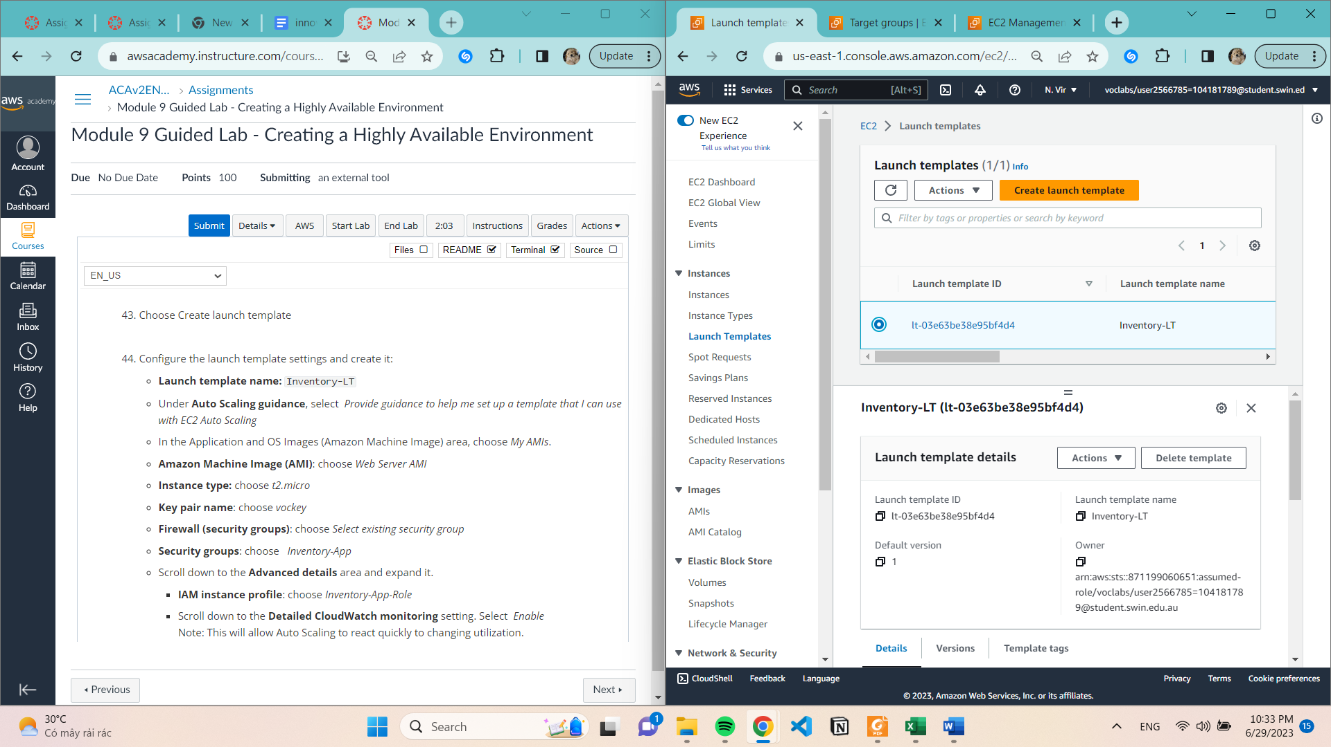

**Create Auto Scaling Group**

**Step 1**

* **Auto Scaling group name: Inventory-ASG**
* **Launch template: Inventory-LT template you just created is selected.**

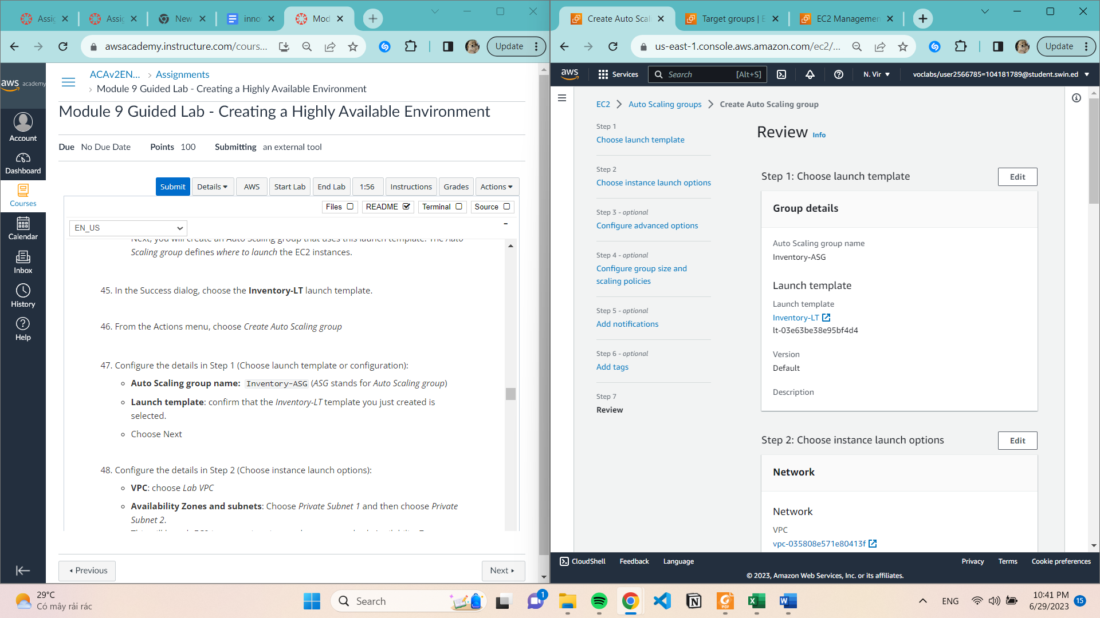

**Step 2**

* **VPC**: choose Lab VPC
* **Availability Zones and subnets:** Choose Private Subnet 1 and then choose Private Subnet 2.

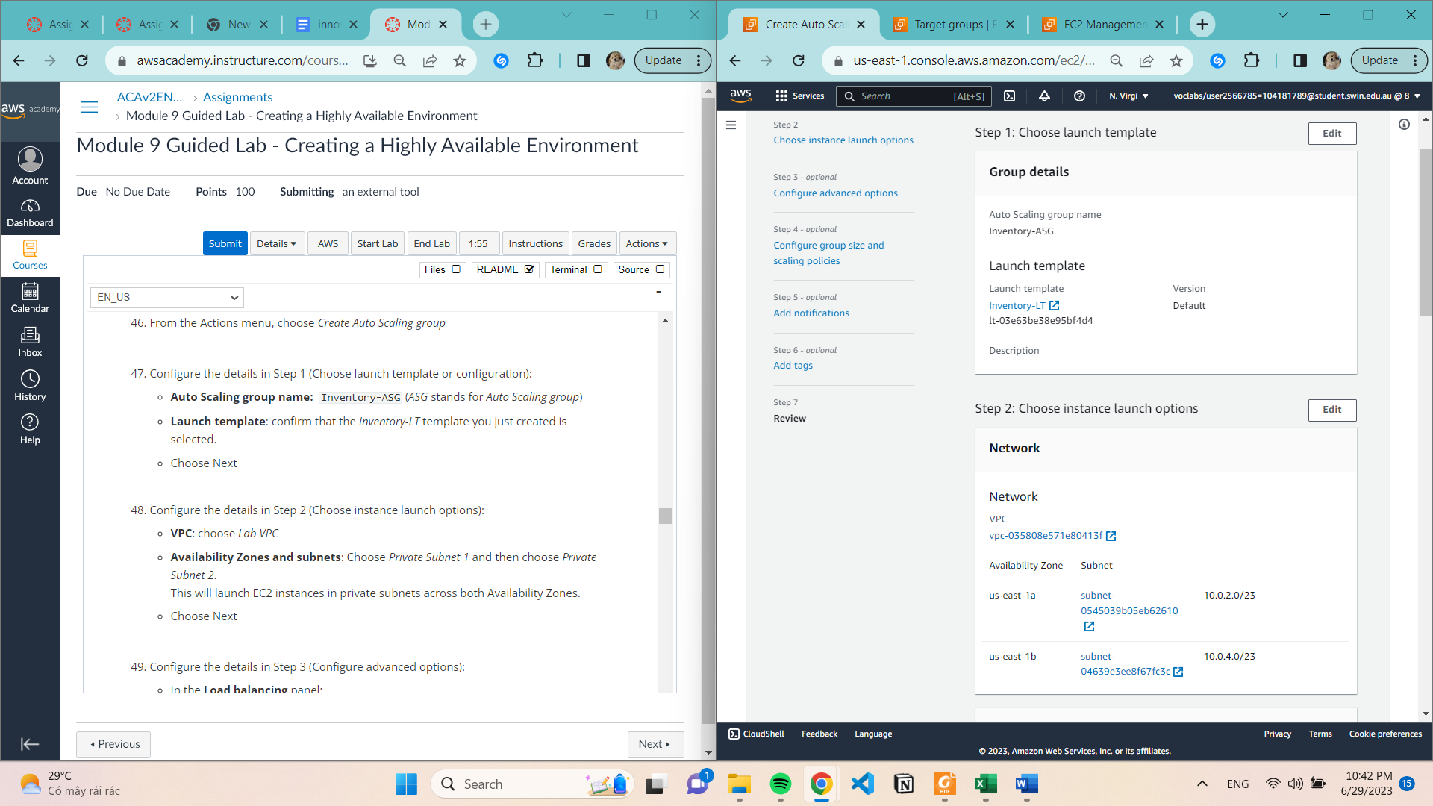

**Step 3**

* In the **Load balancing panel**:
* Choose **Attach to an existing load balancer**
* **Existing load balancer target groups**: select Inventory-App.
* In the **Health checks** panel:
* **Health check grace period:** 90 seconds
* In the **Additional settings** panel:
* Select **Enable group metrics collection within CloudWatch**

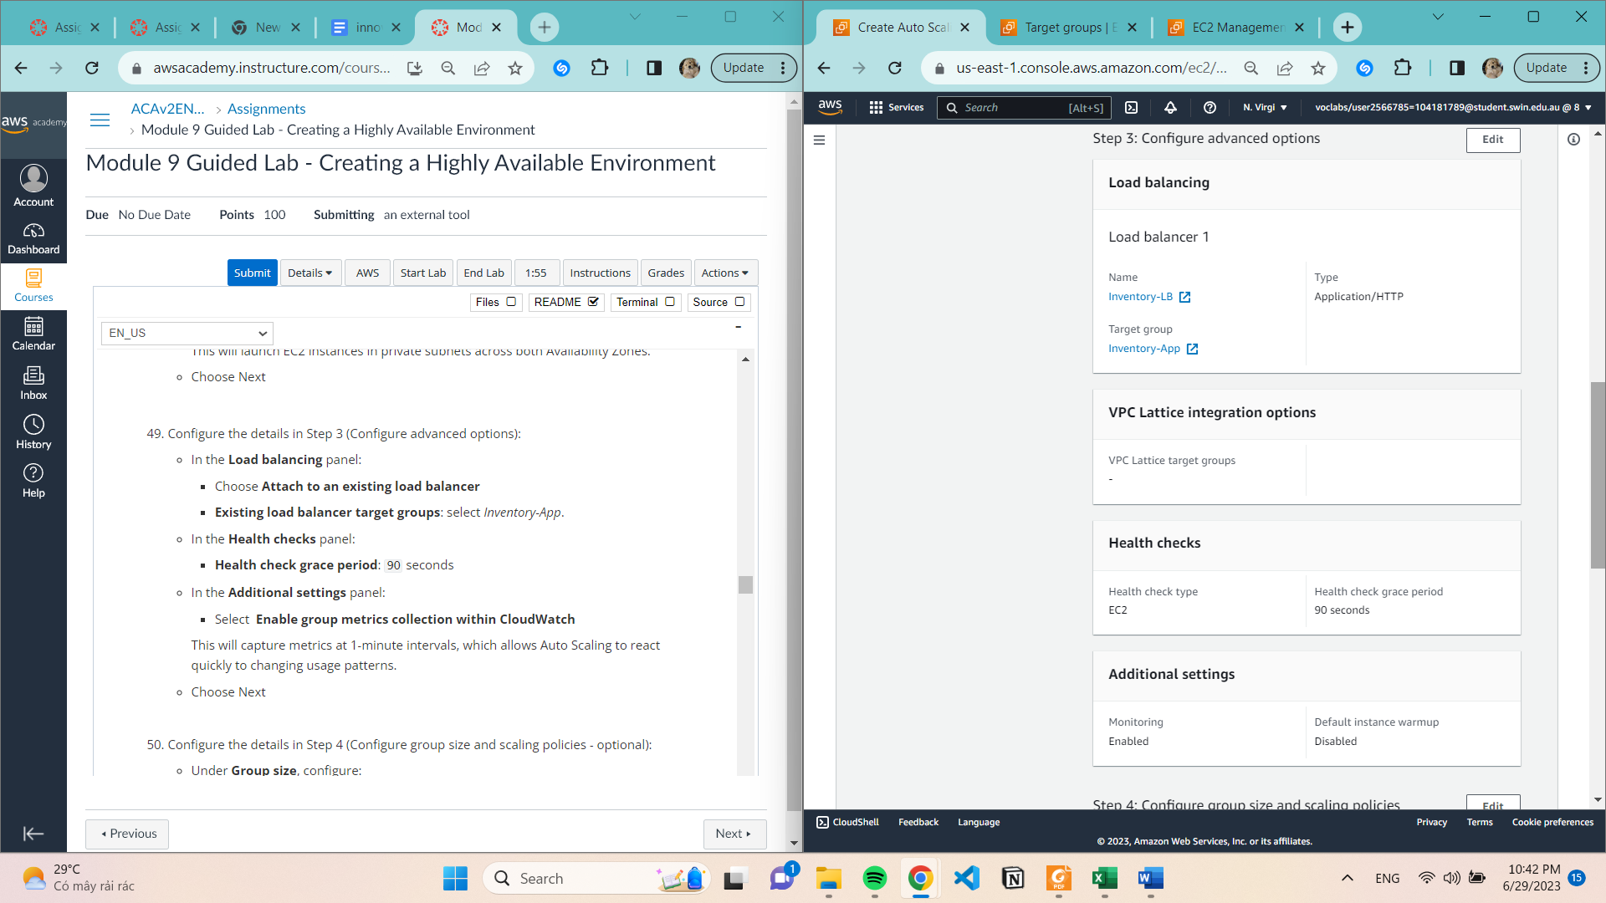

**Step 4**

* Under **Group size,** configure:
* **Desired capacity:** 2
* **Minimum capacity:** 2
* **Maximum capacity:** 2
* Under **Scaling policies**, choose None

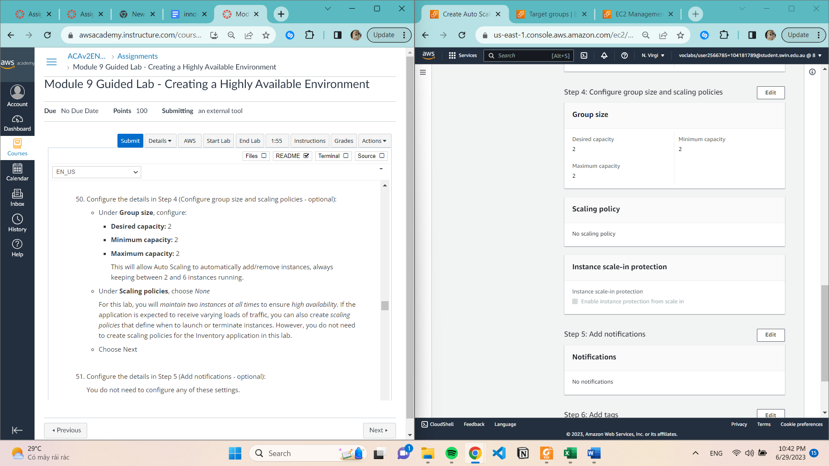

**Step 5,6**

Choose Add tag and Configure the following:

**Key**: Name

**Value:** Inventory-App

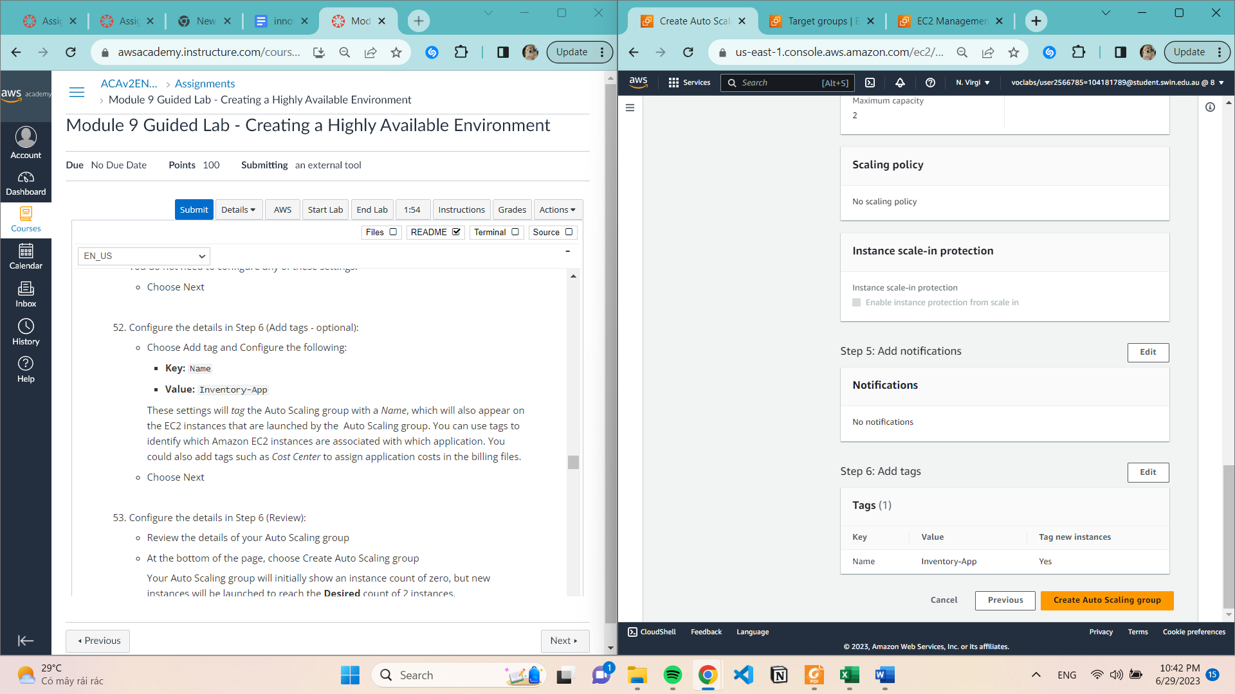

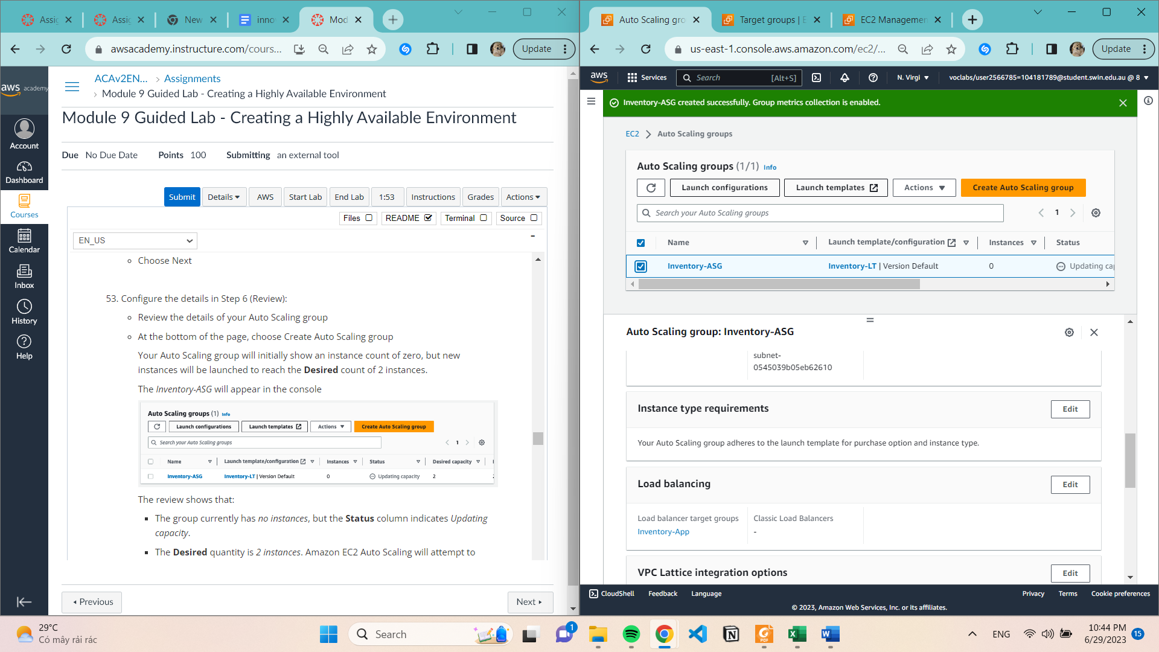

**Task 4: Updating security group**

**Application security group**

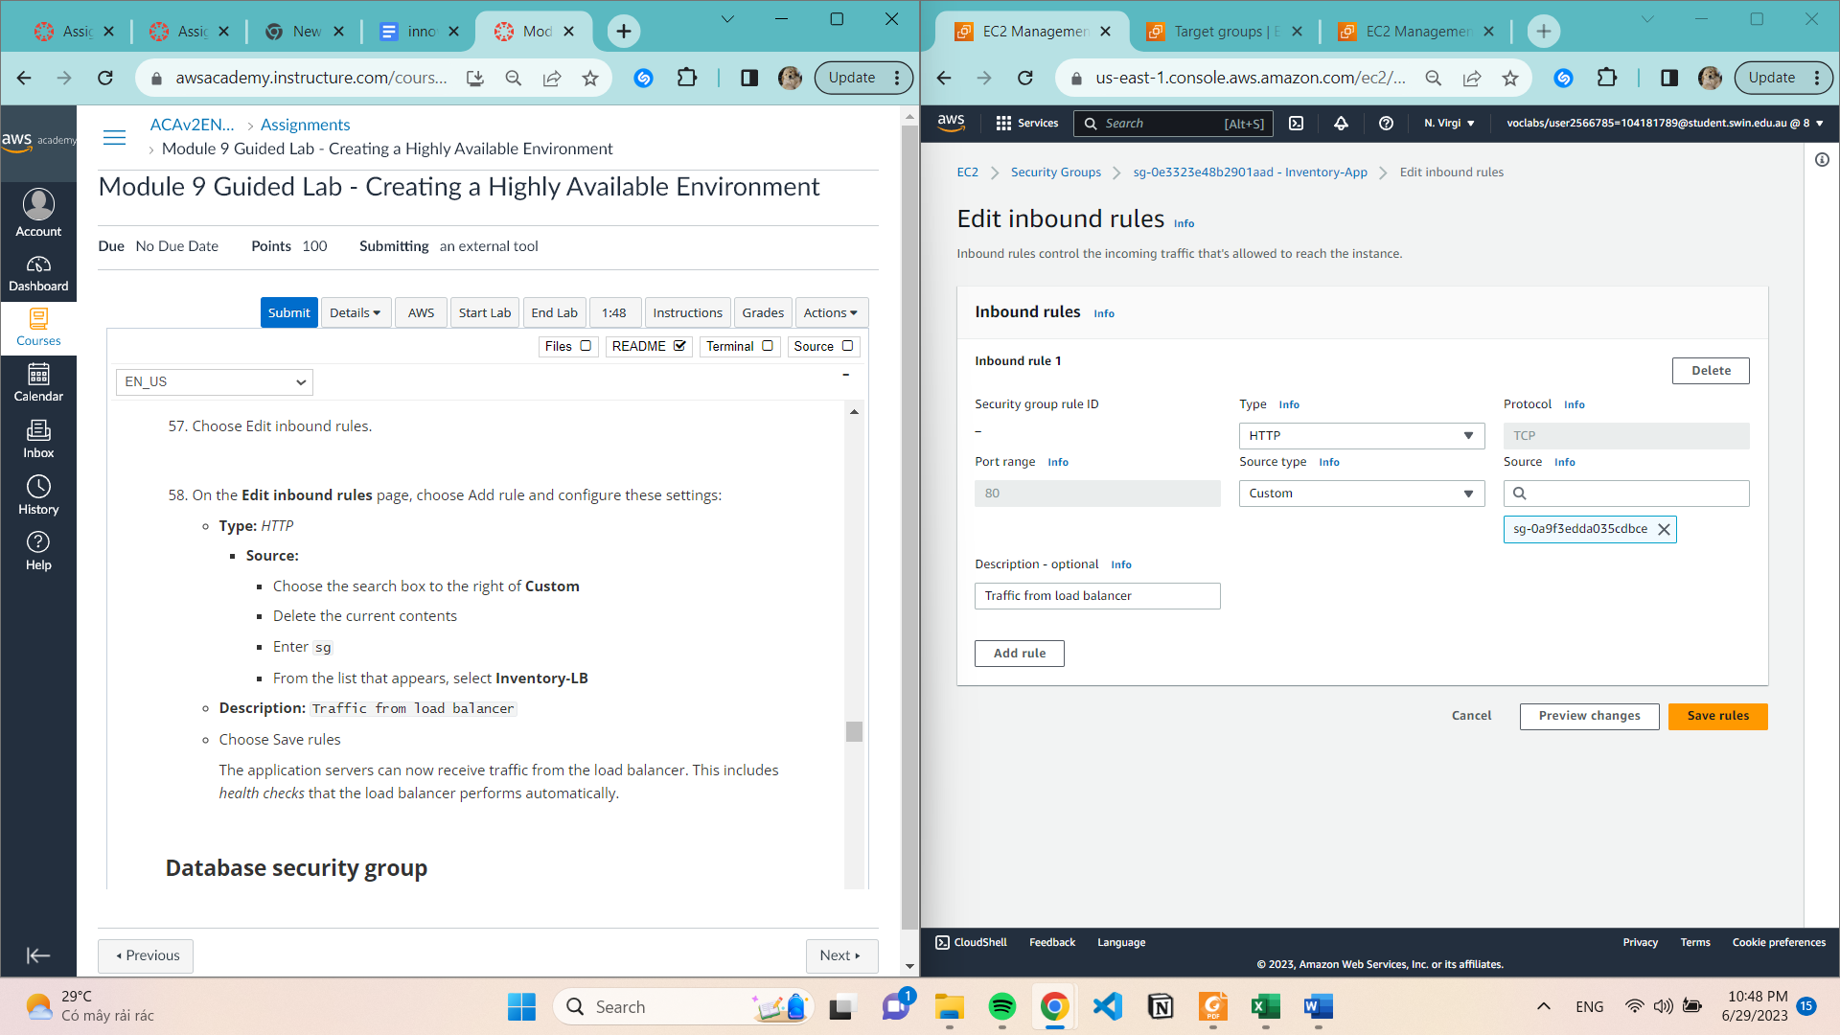

Database security group (Create inbound rules)

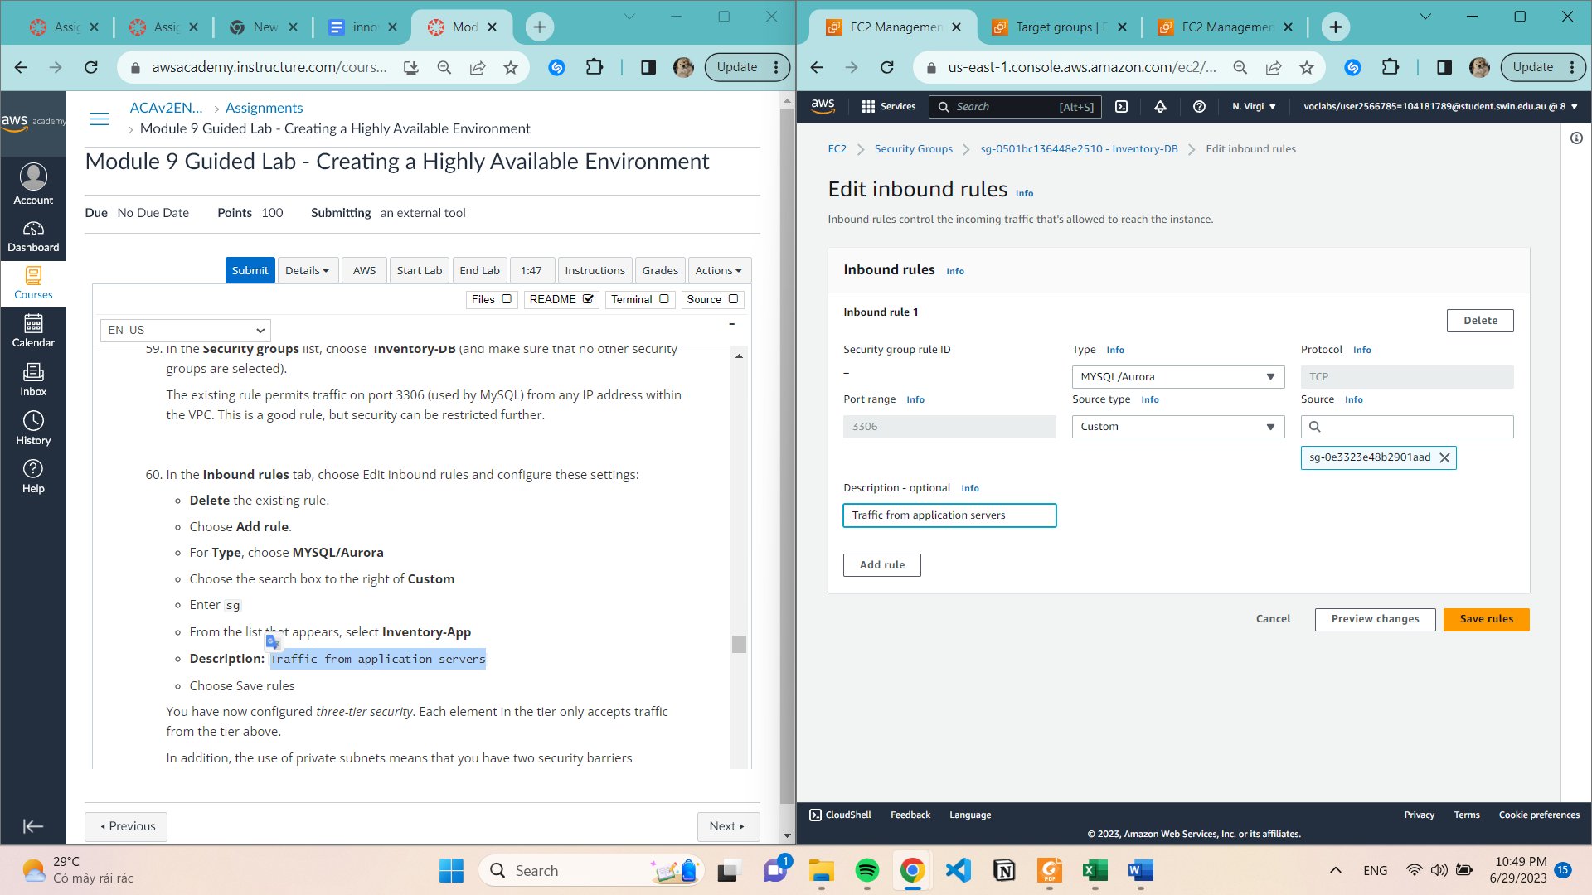

Task 5: Testing the application

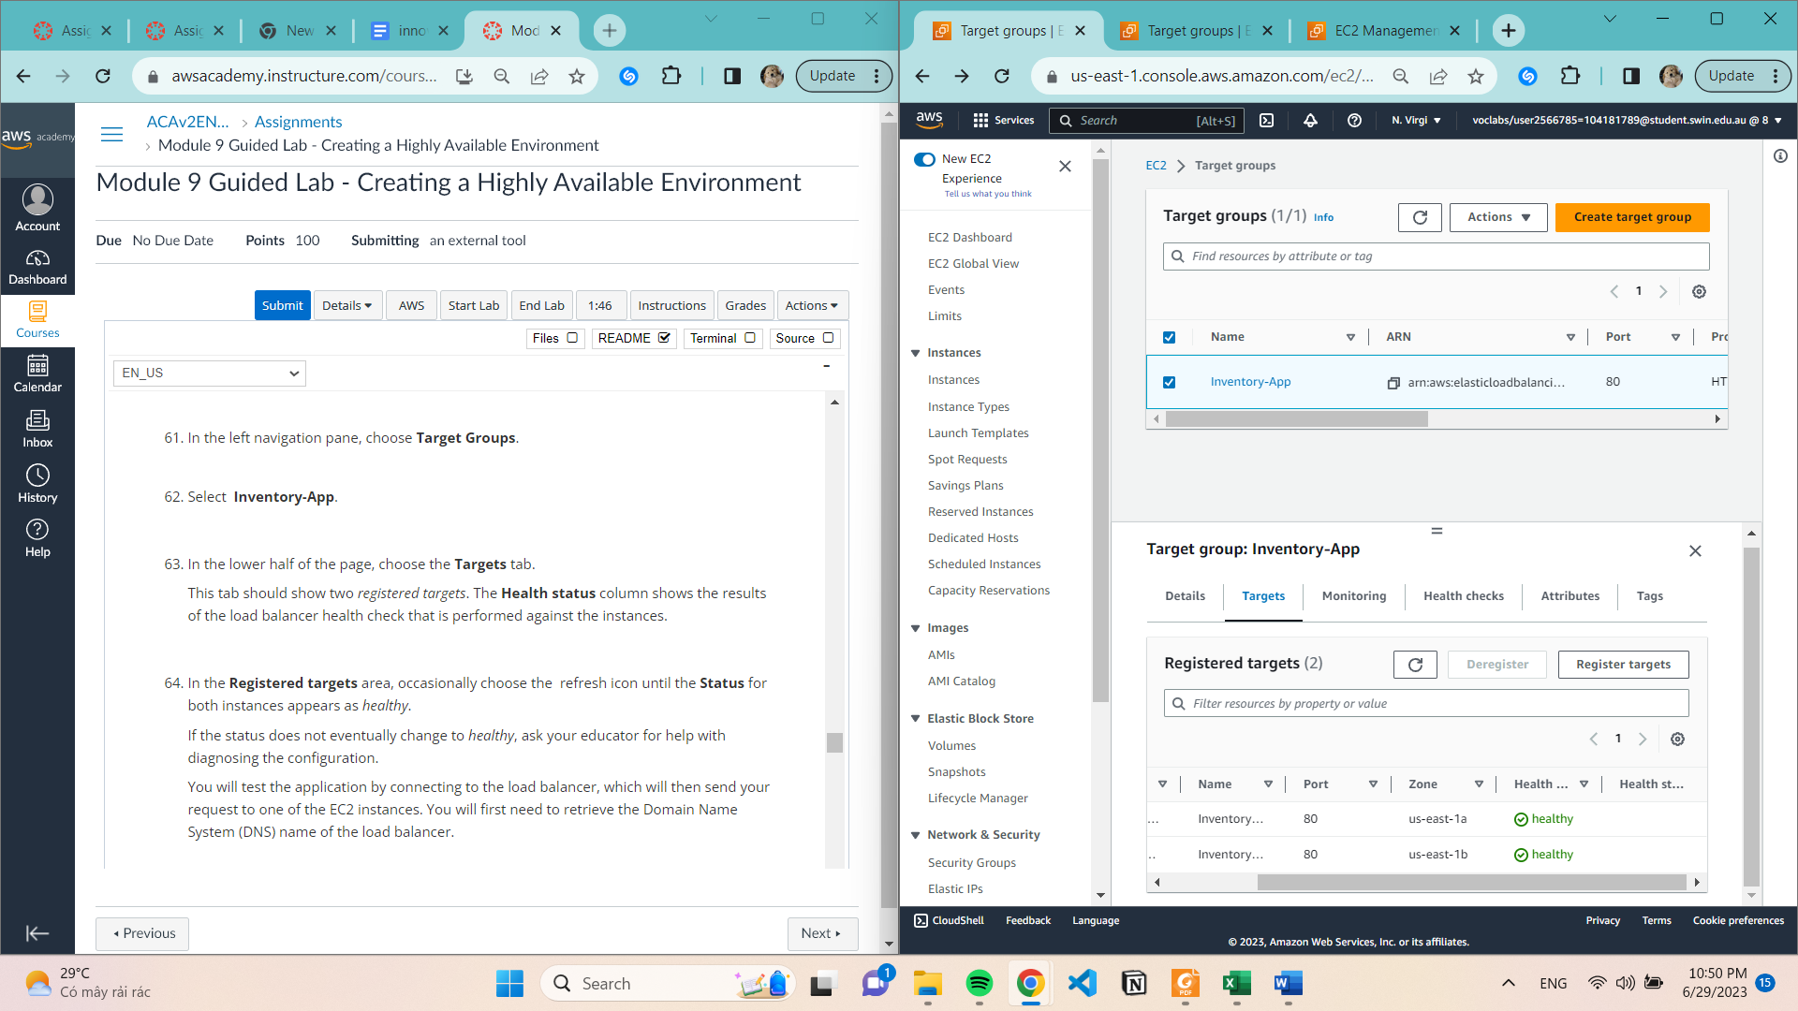

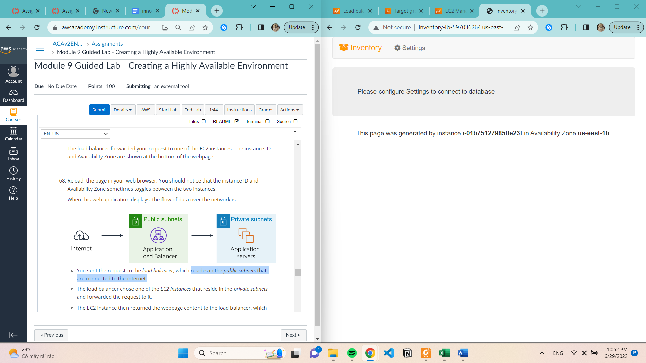

Task 6: Testing high availability

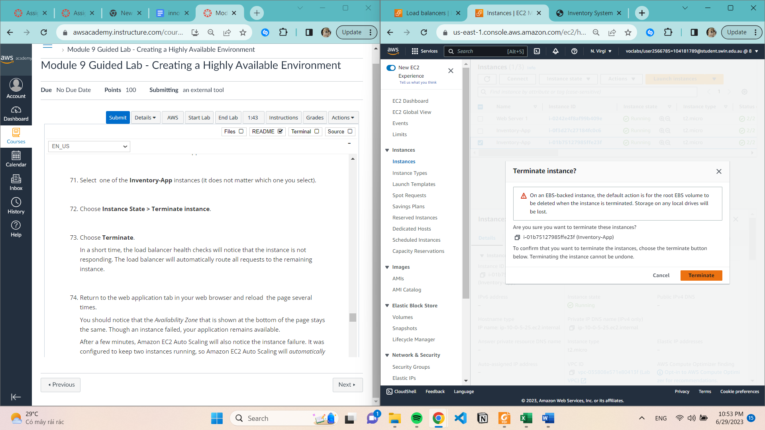

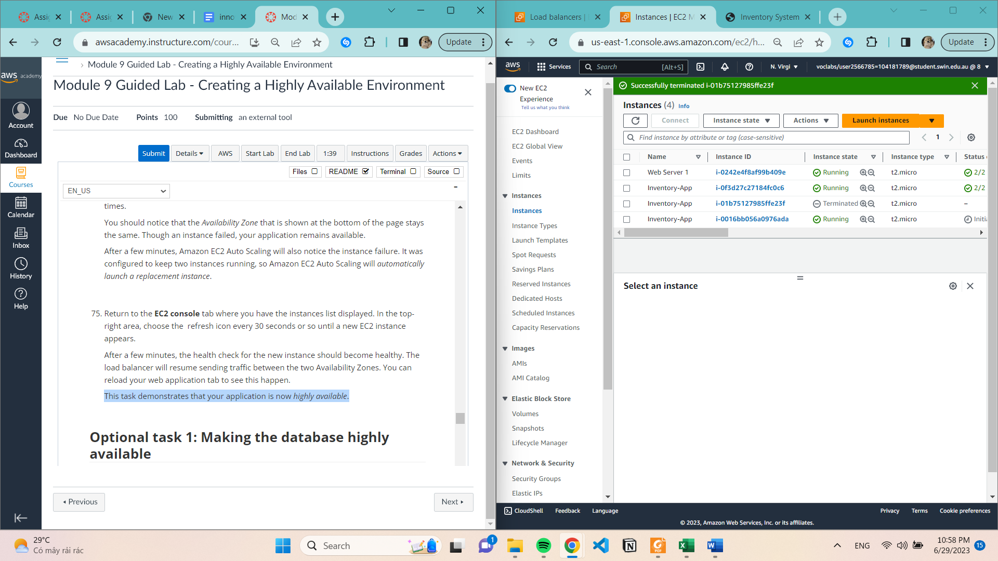

Optional task 1: Making the database highly available

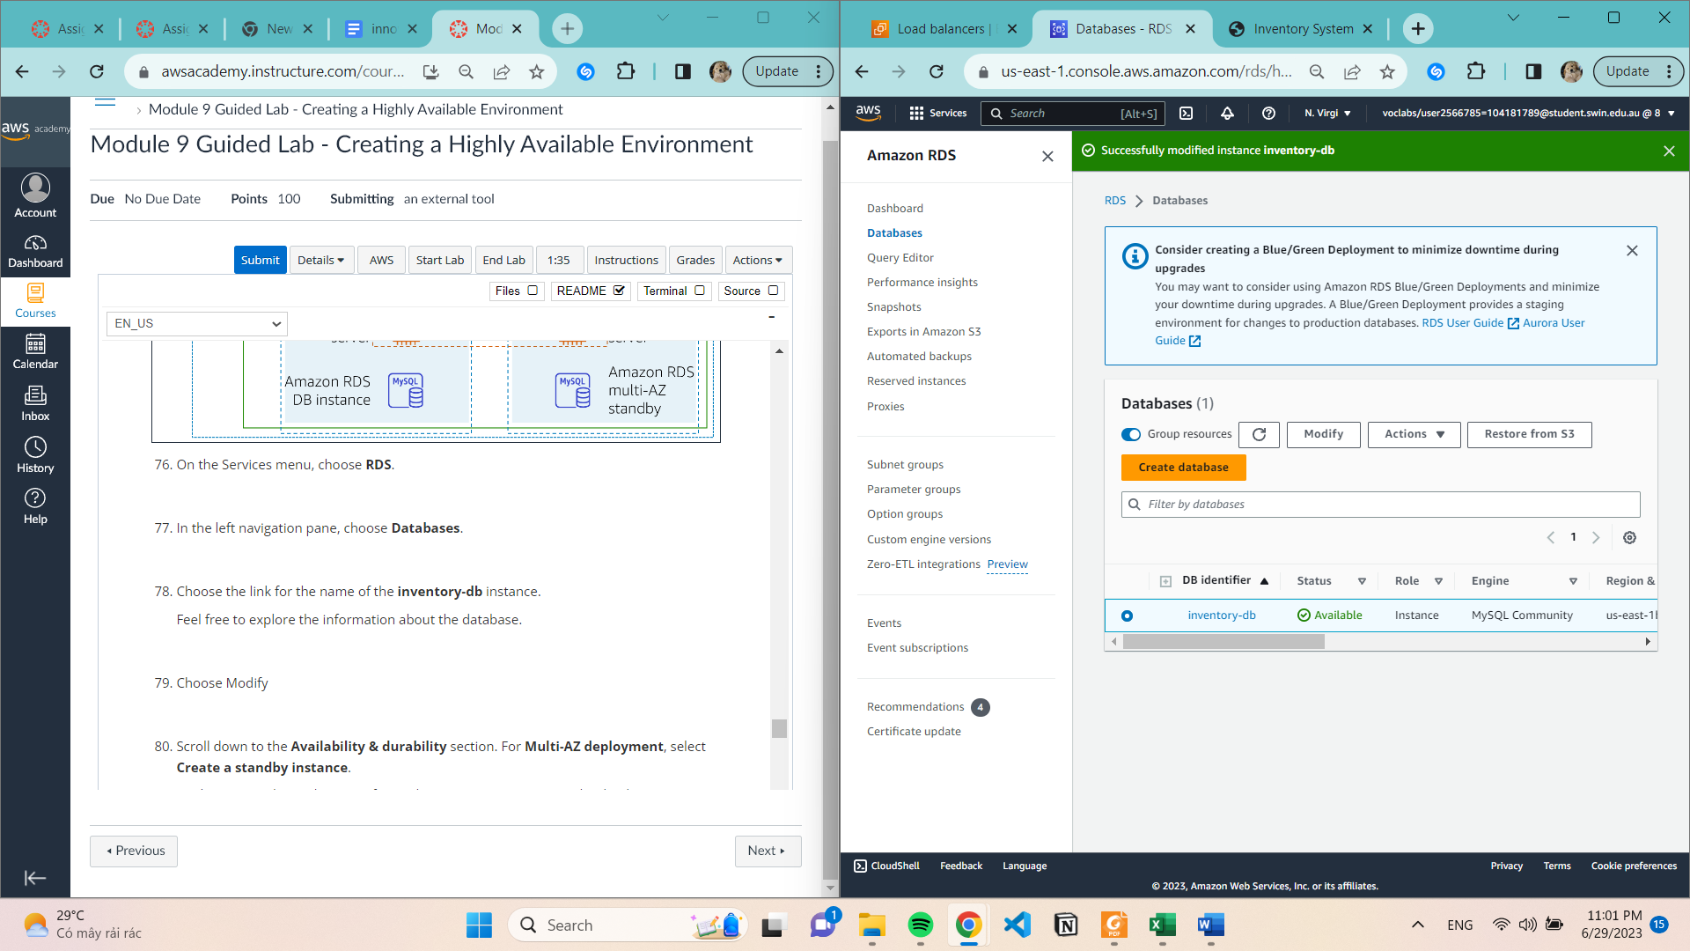

Optional task 2: Configuring a highly available NAT gateway

Create NAT gateway

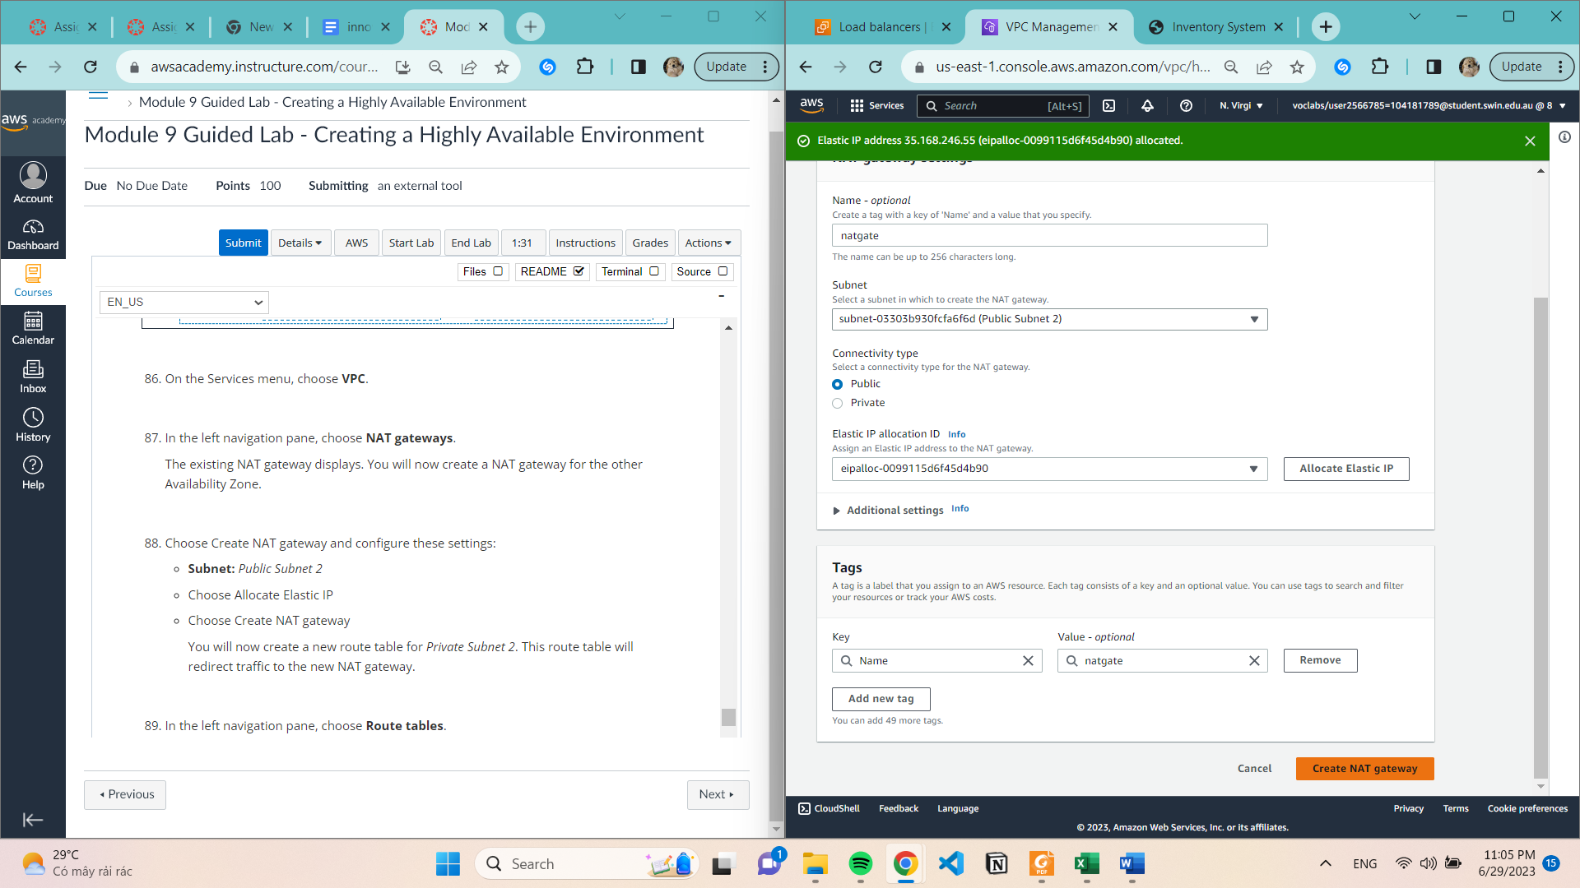

Create route table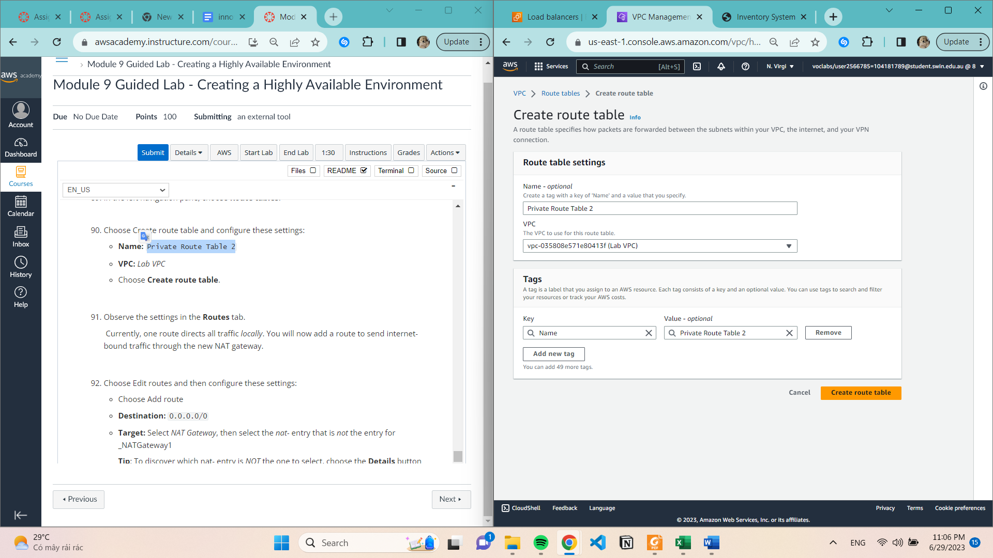

Edit routes

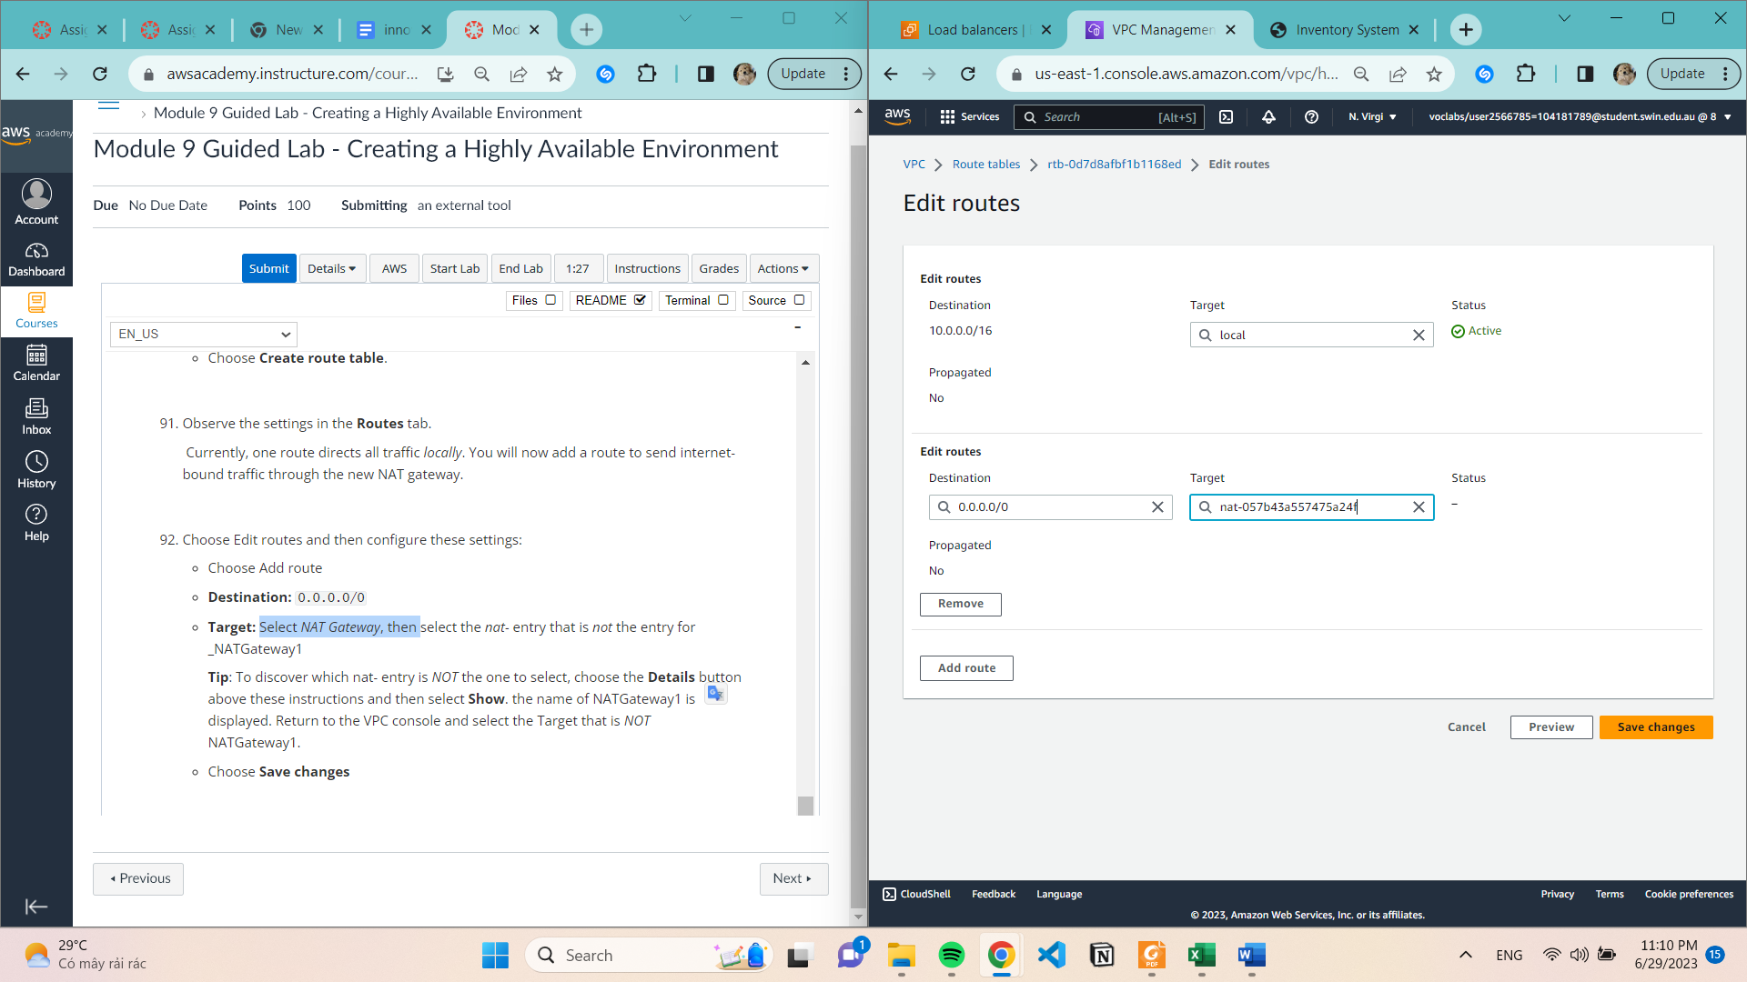

Save subnet association

